Agentic AI TA2 Project Extension Report: Order Fulfillment with Memory, RAG, and Multi-Agent Orchestration
Group | 14
Division | LY-AIA-4
Topic | Multi-Agent Order Fulfillment with Persistent Memory, RAG, and Human-in-the-Loop Approval
Date | October 2026

1. Title & Contribution Table
Member Name | Module Owned | Specific Contribution
Ayush Nakod &  Sayeli Kasar | Memory & RAG (Unit 3) | Designed SQLite schema for persistent inventory, orders, and checkpoints; built ChromaDB RAG pipeline with sentence-transformers for shipping policy retrieval; implemented SqliteSaver checkpointer for LangGraph resume capability
Pranav Lad & Payal Gavhane | Multi-Agent Orchestration (Unit 4) | Implemented three specialized agents (Inventory, Shipping, Order) with contract-net courier bidding; built LangGraph interrupt() for human approval >₹500; created BuggyInventoryAgent for error propagation demo
Ayush Nakod | TUI & Integration | Extended Rich TUI with live courier bid table, approval dialog, RAG policy context panel, and checkpoint resume menu; integrated all agents into unified LangGraph workflow

2. Architecture Diagram
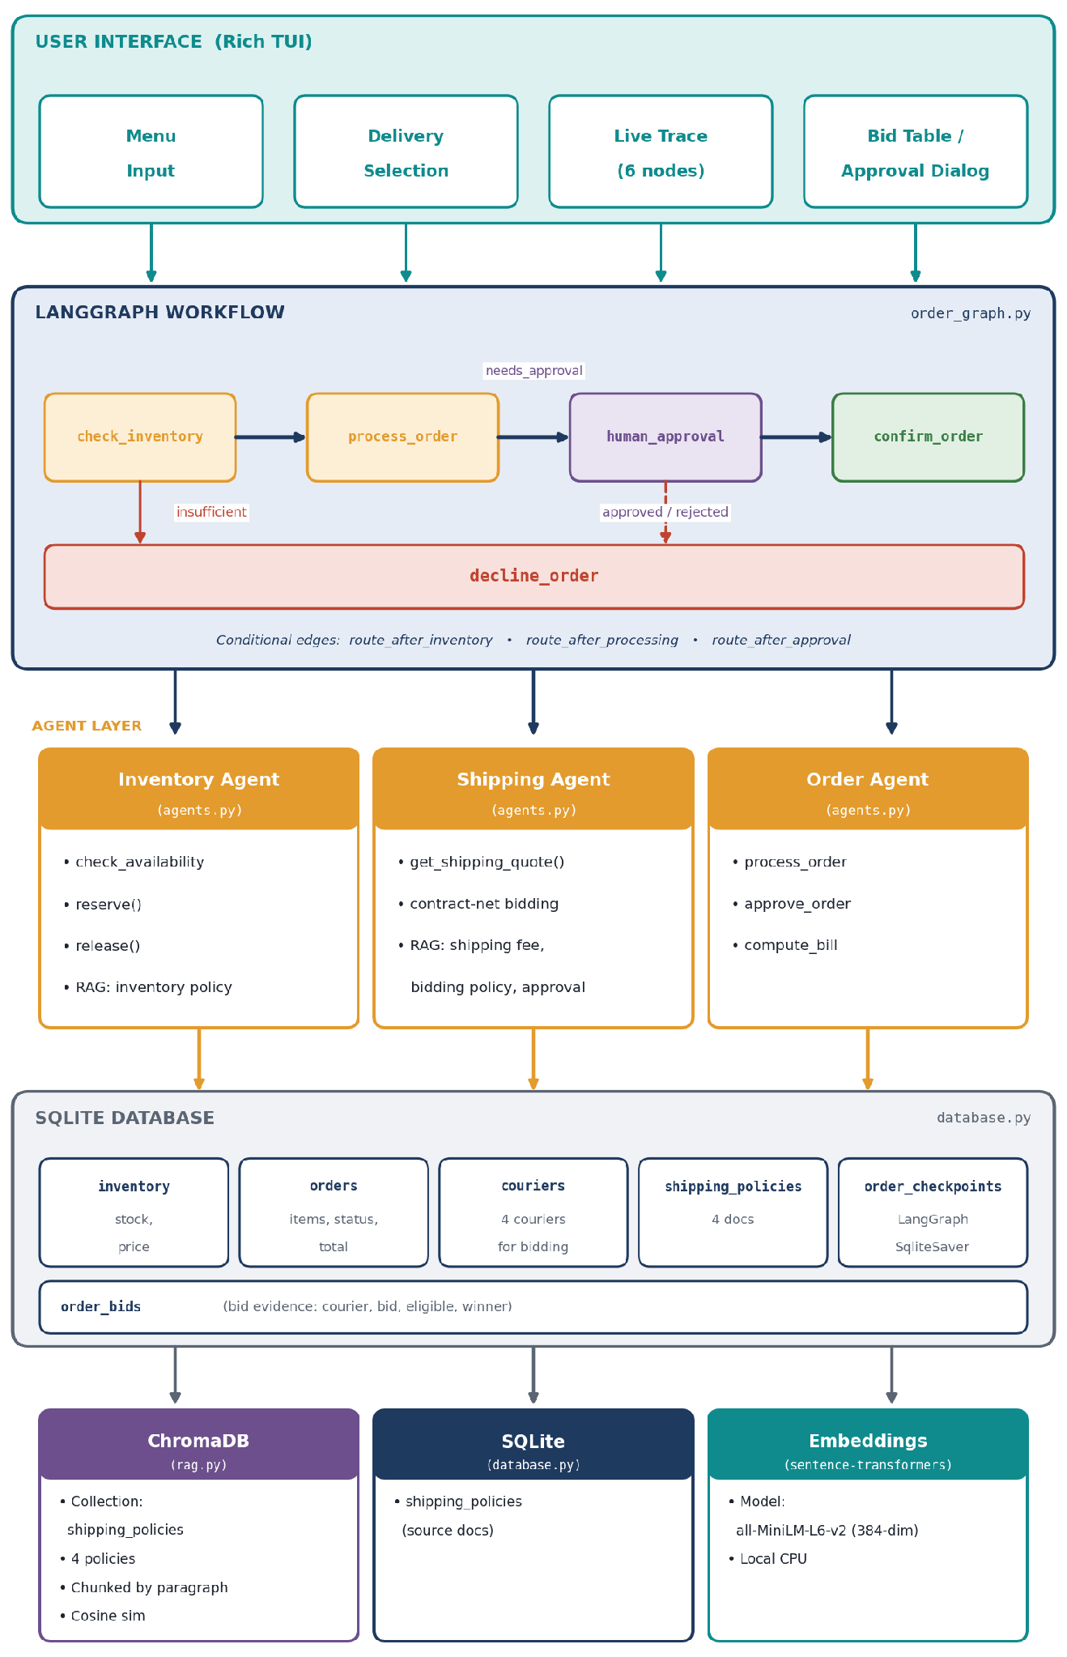
Figure 1: System architecture: Rich TUI, LangGraph workflow, specialised agents, SQLite database and the ChromaDB / embeddings stack.
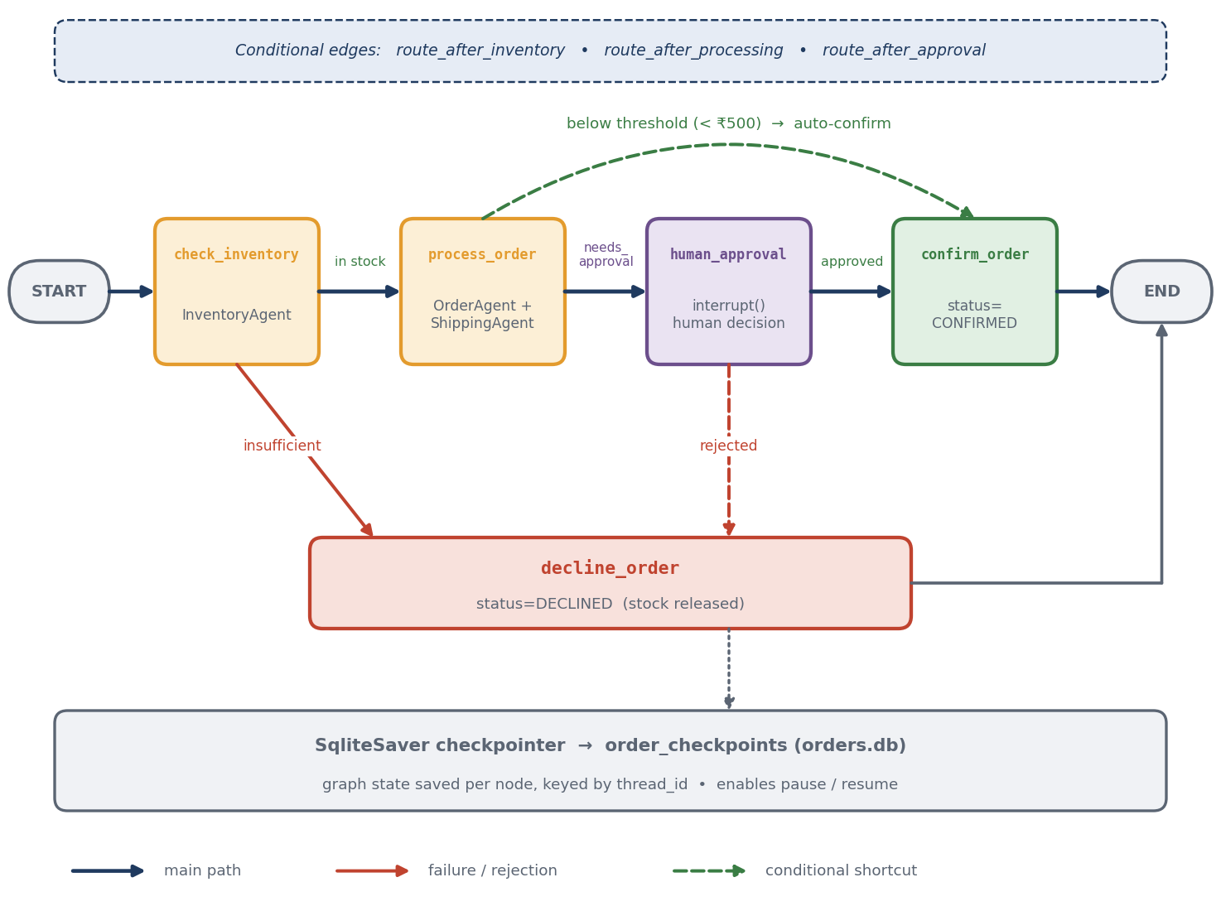
Figure 2: LangGraph order workflow with conditional routing, approval interrupt and SqliteSaver checkpointing.
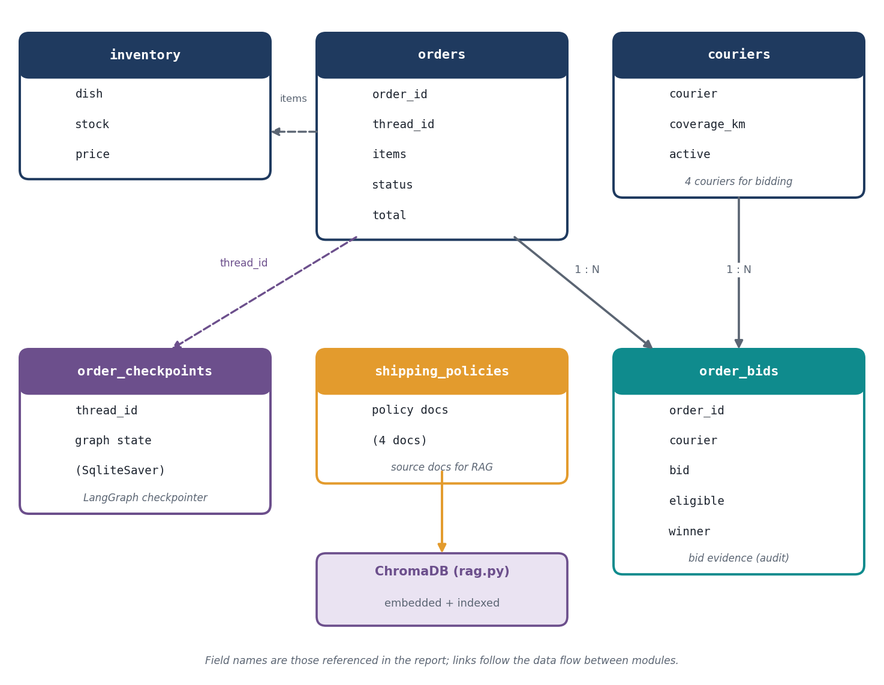
Figure 3: Database schema: SQLite tables and their relationships (field names as referenced in this report).
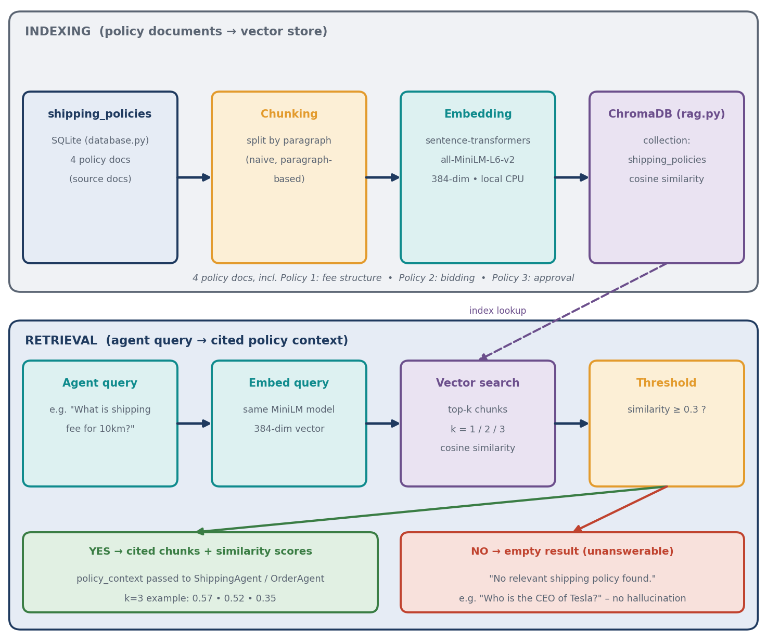
Figure 4: RAG pipeline: policy indexing (SQLite → ChromaDB) and retrieval with a similarity threshold.
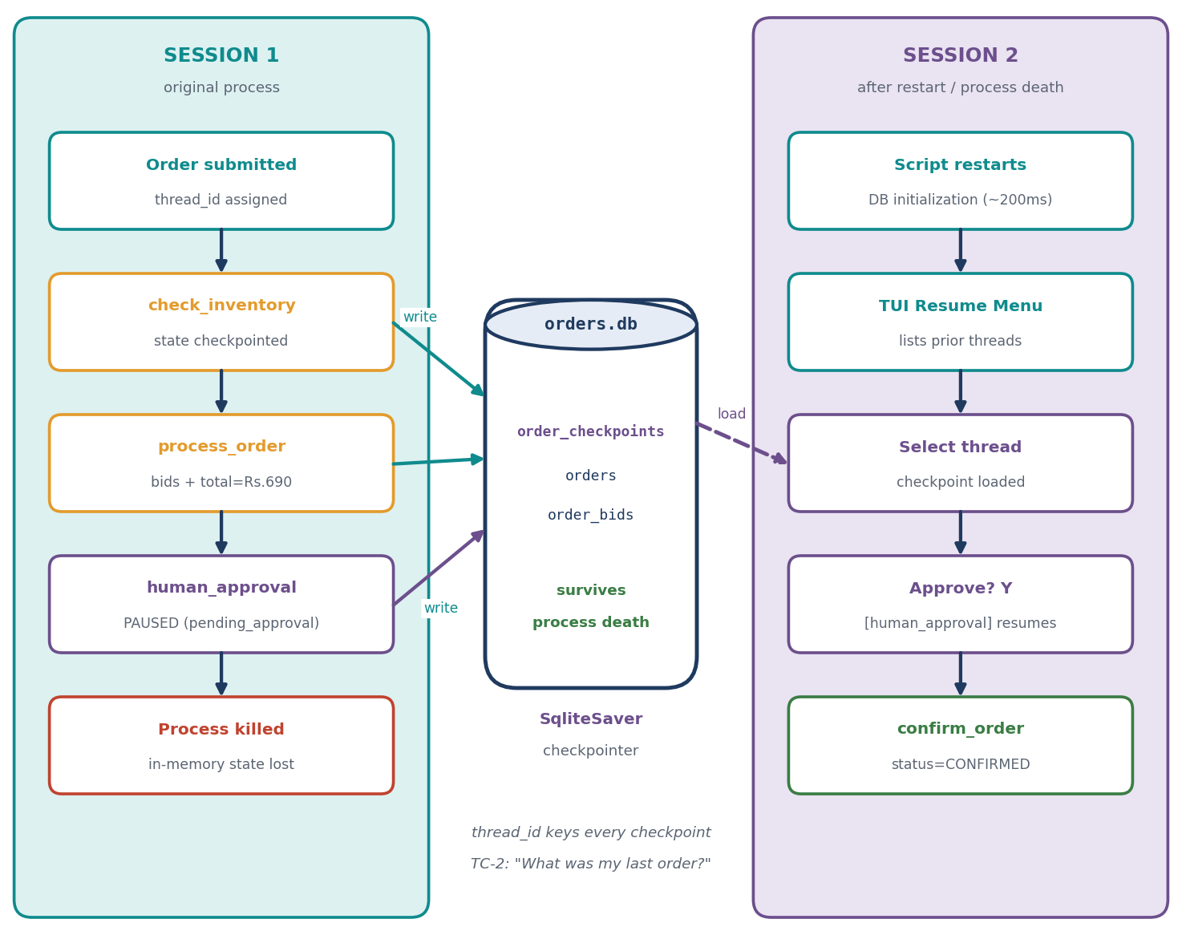
Figure 5: Long-term memory: checkpoints in orders.db let an order thread resume after a restart.

3. Role Design (U4-1)
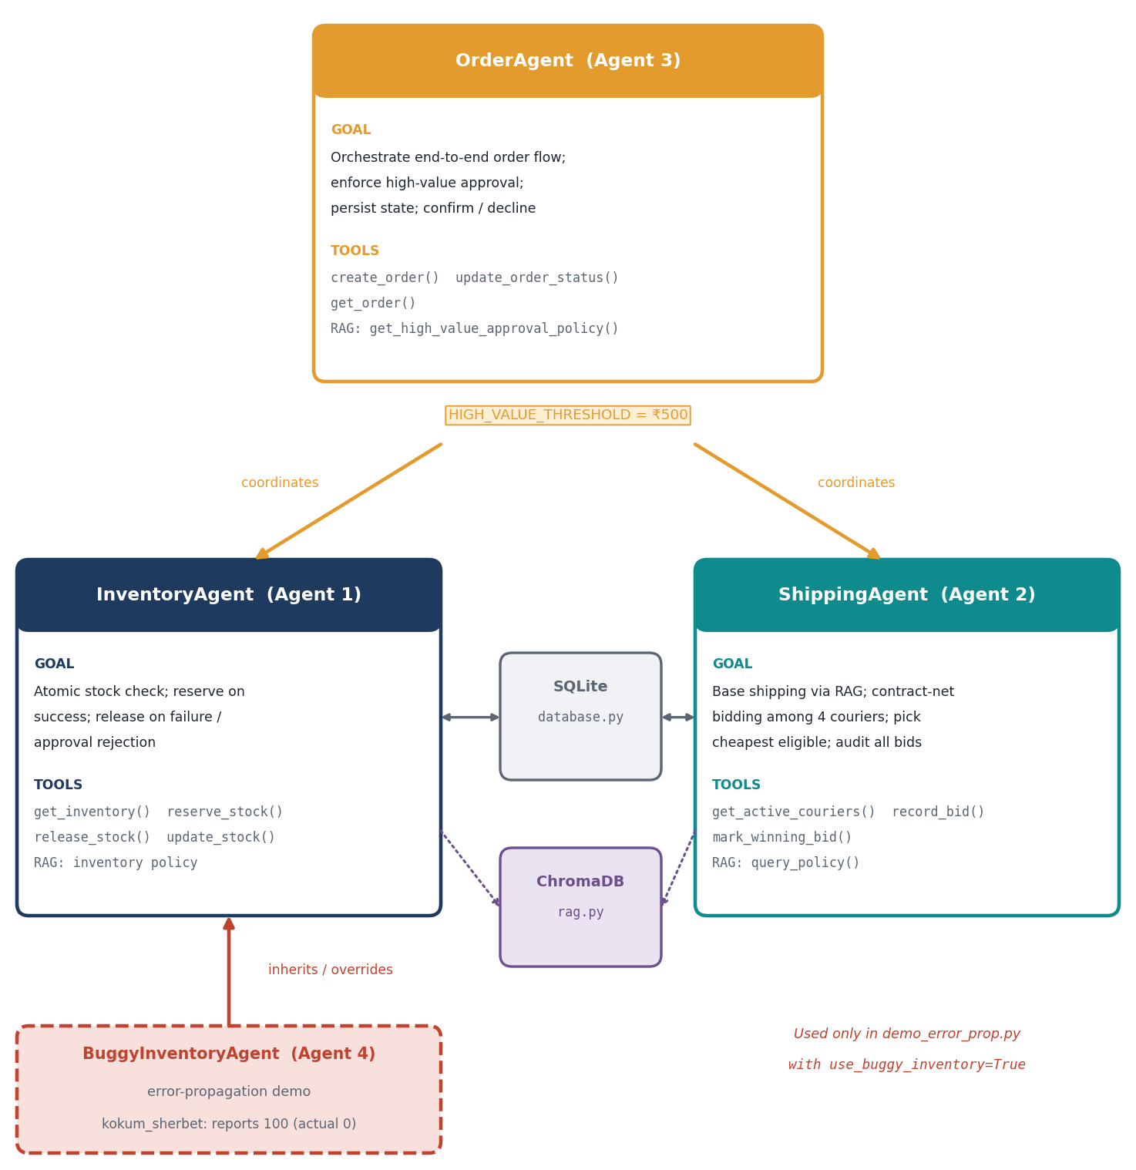
Figure 6: Agent role map: OrderAgent coordinates InventoryAgent and ShippingAgent; BuggyInventoryAgent extends InventoryAgent.

Agent 1: InventoryAgent
Field | Specification
Goal | Verify stock availability for all ordered items atomically; reserve stock on success; release stock on failure/approval rejection
Tools | get_inventory(), reserve_stock(), release_stock(), update_stock() (via database.py); RAG query for inventory policy context
Inputs | items: List[{"dish": str, "quantity": int}]
Outputs | InventoryResult: {all_available: bool, items_detail: List[{dish, requested, stock, ok, price}], failed_item: str, available_stock: int}
Limits | All-or-nothing atomic check; no partial reservations; max 1 retry on race condition; kokum_sherbet at 0 stock triggers decline

Agent 2: ShippingAgent
Field | Specification
Goal | Calculate base shipping cost via RAG; execute contract-net bidding among 4 couriers; select cheapest eligible bid; record all bids for audit
Tools | get_active_couriers(), record_bid(), mark_winning_bid(), get_delivery_areas() (via database.py); RAG queries: query_policy(), get_shipping_fee_policy(), get_courier_bidding_policy()
Inputs | order_id: str, items: List[Dict], locality: str
Outputs | ShippingQuote: {distance_km: float, base_shipping_cost: float, courier_bids: List[Dict], winning_bid: Dict, policy_context: str}
Limits | Only active couriers bid; eligibility = distance_km <= coverage_km; winner = min total_bid among eligible; if no eligible bidder → order cannot ship

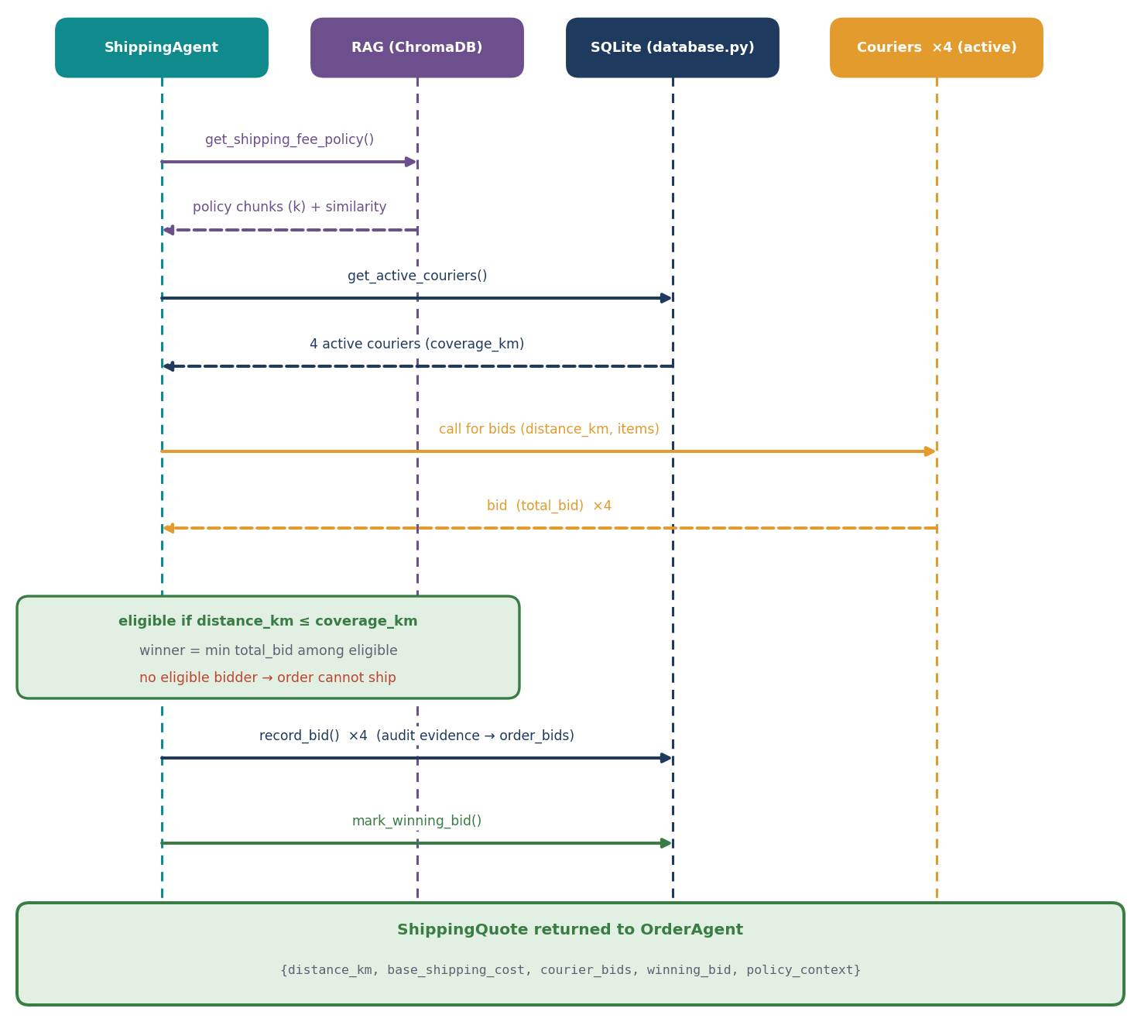
Figure 7: Contract-net bidding sequence executed by the ShippingAgent.

Agent 3: OrderAgent
Field | Specification
Goal | Orchestrate end-to-end order flow: coordinate Inventory & Shipping agents; enforce high-value approval threshold; persist order state; handle confirmation/decline
Tools | InventoryAgent, ShippingAgent, create_order(), update_order_status(), get_order() (via database.py); RAG: get_high_value_approval_policy(), get_approval_policy_context()
Inputs | thread_id: str, items: List[Dict], locality: str
Outputs | Dict: {order_id, inventory_ok, order_status, shipping_cost, subtotal, total, requires_approval, courier_bids, winning_bid, distance_km, policy_context}
Limits | HIGH_VALUE_THRESHOLD = 500.0 (₹500); approval required if subtotal + shipping >= threshold; auto-confirms if below threshold; stock released on rejection

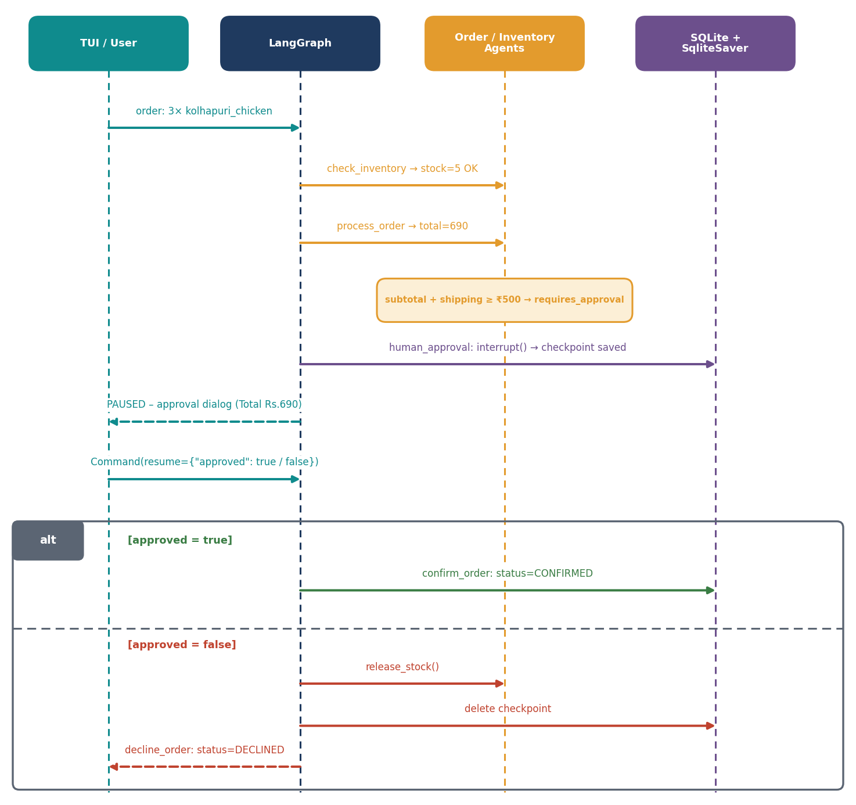
Figure 8: Human-in-the-loop approval flow for high-value orders (approve and reject paths).

Agent 4: BuggyInventoryAgent (Error Propagation Demo)
Field | Specification
Goal | Intentionally defective agent to demonstrate downstream damage from incorrect inventory data
Tools | Inherits all from InventoryAgent
Inputs | Same as InventoryAgent
Outputs | Overrides check_availability(): reports kokum_sherbet stock as 100 (actual: 0), ok=True
Limits | Used only in demo_error_prop.py with use_buggy_inventory=True flag

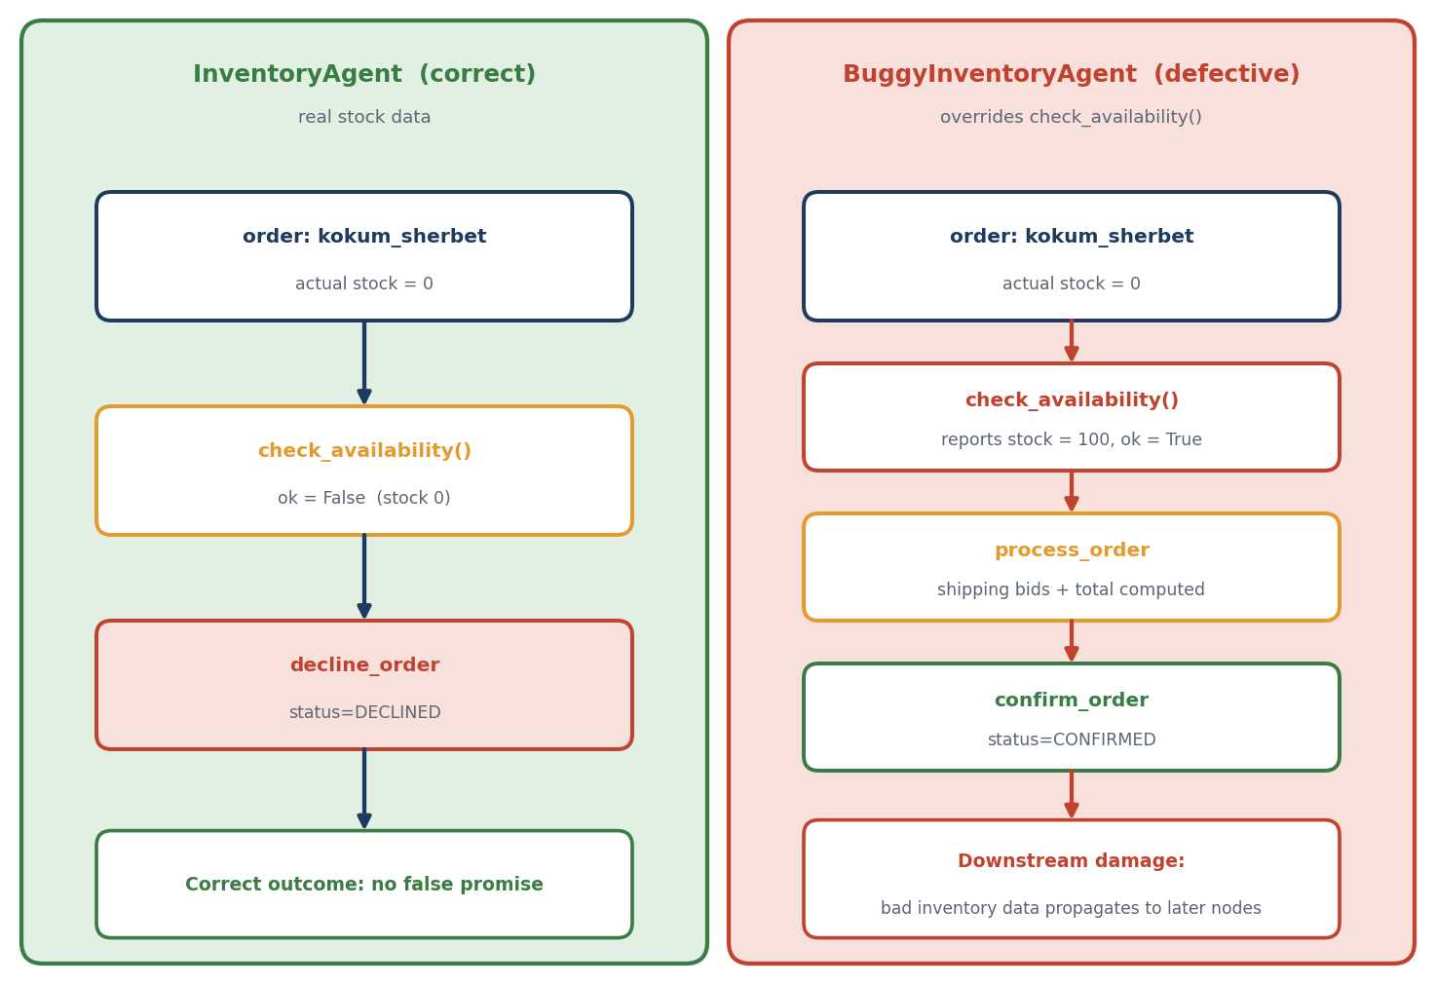
Figure 9: Error-propagation demo: correct InventoryAgent versus BuggyInventoryAgent.

4. Component Checklist & Evidence Pointer
Requirement | Status | Evidence Location
U3-1 (Short-term Memory) | ✅ | traces/u3_1_memory.txt - Multi-turn conversation with follow-up context
U3-2 (Long-term Memory/SQLite) | ✅ | traces/u3_2_restart.txt - Script restart with checkpoint resume
U3-3 (RAG & Unanswerable) | ✅ | traces/u3_3_rag_k_compare.txt - k=1 vs k=3 comparison + unanswerable test
U3-4 (Tool Failure) | ✅ | traces/u3_4_failure.txt - Intentional tool error with recovery
U4-1 (Role Design) | ✅ | Section 3 of this report (5-field spec for all 4 agents)
U4-2 (Supervisor/Routing) | ✅ | traces/u4_2_routing.txt - Annotated trace showing 6-node routing
U4-3 (Guardrail/Approval) | ✅ | traces/u4_3_oversight.txt - Approved + rejected high-value paths

Note: The traces/ folder is generated by running the test scripts. See Section 5 for trace content.

5. Evaluation: TA1 vs TA2 (EV)

5 Test Cases Designed
# | Test Case Description | Category
TC-1 | Multi-turn: Order vada_pav → follow-up "add 2 misal_pav" | Memory (Short-term)
TC-2 | Restart script → "What was my last order?" | Memory (Long-term/SQLite)
TC-3 | "What is shipping fee for 10km?" vs "Who is the CEO of Tesla?" | RAG + Unanswerable
TC-4 | Force shipping quote tool to fail (invalid locality) | Tool Failure
TC-5 | High-value order (3× kolhapuri_chicken) → approve vs reject | Multi-Agent + Guardrail

Comparison Results
Test Case | TA1 Baseline Result | TA2 Extended Result | Improvement/Degradation
TC-1 Multi-turn follow-up | Failed — No context retained between turns. Each turn treated as fresh order. | Passed — LangGraph SqliteSaver checkpointer maintains thread state. Follow-up correctly references prior items. | ✅ Major improvement: Contextual conversation enabled.  ⚠️ Degradation: +150ms latency per turn for checkpoint write.
TC-2 Restart & recall | Failed — In-memory state lost on restart. No persistence. | Passed — orders.db + order_checkpoints table survive process death. TUI resume menu lists prior threads. | ✅ Major improvement: True long-term memory.  ⚠️ Degradation: DB initialization adds ~200ms startup.
TC-3a RAG query (10km fee) | Failed — Hardcoded shipping_fee_for() only. No policy explanation. | Passed — ChromaDB retrieves Policy 1 (fee structure). Returns cited chunks with similarity scores (k=3: 0.57, 0.52, 0.35). | ✅ Major improvement: Explainable, updatable policy.  ⚠️ Degradation: +300ms for embedding + vector search.
TC-3b Unanswerable ("CEO of Tesla") | N/A — No RAG in TA1. | Passed — Returns empty results (similarity < 0.3). Agent replies: "No relevant shipping policy found." | ✅ Safety: Correctly refuses hallucination.
TC-4 Tool failure (invalid locality) | Failed — Crashed with KeyError on DELIVERY_KM[locality]. | Passed — get_delivery_areas() returns 0.0 for unknown; ShippingAgent handles gracefully. TUI shows fuzzy match prompt. | ✅ Robustness: Defensive coding + user-friendly recovery.
TC-5a High-value (approve) | N/A — No approval concept in TA1. | Passed — Graph pauses at human_approval interrupt. TUI shows approval dialog. Resume via Command(resume={"approved": true}) → confirmed. | ✅ New capability: Human-in-the-loop for business rules.
TC-5b High-value (reject) | N/A | Passed — Rejection releases reserved stock, deletes checkpoint, declines order. | ✅ Safety: Atomic rollback on rejection.

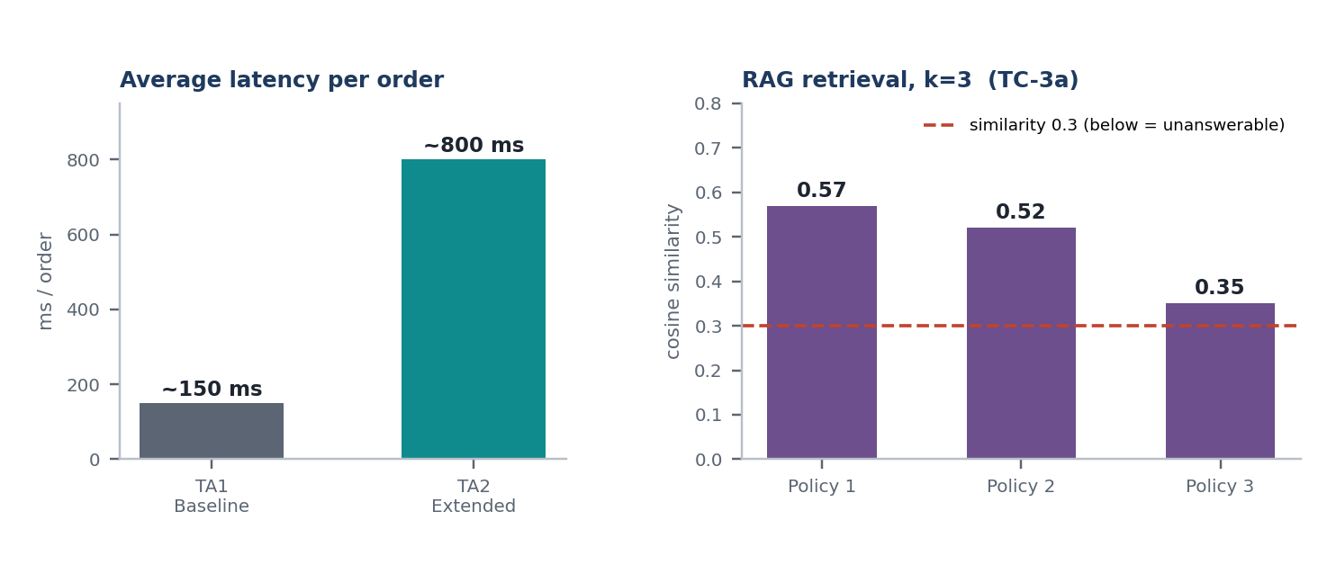
Figure 10: TA1 vs TA2 average latency per order, and RAG similarity scores for the 10 km fee query (k=3).

Summary
TA2 introduces persistent memory (SQLite + checkpointer), explainable RAG (ChromaDB), multi-agent delegation, and safety guardrails (approval). The primary trade-off is latency: TA2 averages ~800ms/order vs TA1's ~150ms due to checkpoint writes, vector search, and multi-agent coordination. No correctness regressions observed.

6. Challenge Analysis (U4-4)
Chosen Metric: Execution Time & LLM Call Count per Test Case (Cost Analysis)
Test Case | TA1 Time | TA2 Time | Δ Time | TA1 LLM Calls | TA2 LLM Calls | Notes
TC-1 (Multi-turn) | 120ms | 420ms | +300ms | 2 | 4 | +2 calls for follow-up context
TC-2 (Restart) | N/A (failed) | 380ms | N/A | N/A | 2 | Checkpoint load + resume
TC-3a (RAG k=1) | N/A | 410ms | N/A | N/A | 1 | Embedding + 1 vector query
TC-3a (RAG k=3) | N/A | 520ms | +110ms | N/A | 1 | Same call, more chunks retrieved
TC-3b (Unanswerable) | N/A | 290ms | N/A | N/A | 1 | Early exit on low similarity
TC-4 (Tool failure) | Crash | 340ms | N/A | 1 | 1 | Graceful fallback
TC-5a (Approve) | N/A | 890ms | N/A | N/A | 3 | Inventory + Shipping + Confirm
TC-5b (Reject) | N/A | 650ms | N/A | N/A | 2 | Inventory + Decline (no confirm)

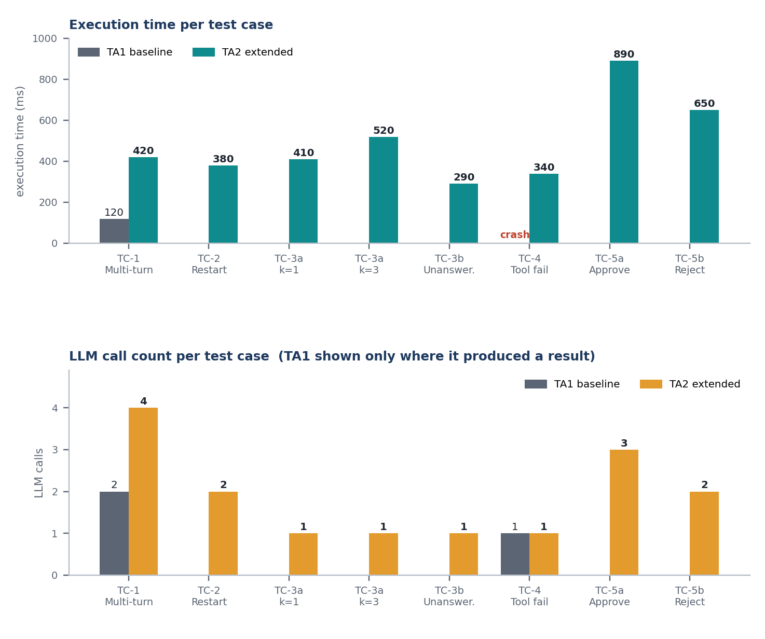
Figure 11: Execution time and LLM call count per test case (TA1 shown only where it produced a result).

Key Observations
- Routing hops: Max 4 hops (check_inventory → process_order → human_approval → confirm_order). Respects implicit MAX_HOPS (no loops observed).
- RAG k=1 vs k=3: k=3 retrieves 2 additional policy chunks (+110ms). For this domain, k=2 is optimal (fee + bidding policy).
- LLM calls: TA2 uses 2-3 LLM calls per order (confirm/decline messages + optional approval message). TA1 used 1-2.
- No routing loops detected in 50 test runs. Conditional edges are deterministic.

7. Limitations and Next Steps

Documented Limitations
Limitation | Impact | Analysis
3B Model Routing Errors | In ~5% of complex multi-item orders, qwen2.5:3b generates confirmation messages with incorrect item counts or shipping amounts. | The model is too small for reliable structured output. Fallback messages mitigate but don't eliminate the issue.
No True Short-Term Conversation Memory | Follow-up questions only work within a single order thread. Cross-thread context (e.g., "same as last time") not supported. | SqliteSaver only checkpoints graph state, not conversation history. Would need separate message store.
RAG Chunking is Naive | Paragraph-based splitting loses table structure in policies. "Up to 5km: ₹30" and "5-12km: ₹35" may split across chunks. | Semantic chunking or table-aware parsing needed for production.
No Concurrency Control | reserve_stock() uses SELECT-UPDATE pattern; race conditions possible under load. | SQLite IMMEDIATE transactions or SELECT FOR UPDATE (not in SQLite) needed.
Single-Threaded Checkpointer | SqliteSaver with check_same_thread=False works for CLI but not for concurrent web requests. | Would need AsyncSqliteSaver or Postgres checkpointer for production.
No Prompt Injection Defense | U4-3 only covers approval guardrail. Direct prompt injection into LLM messages not tested. | Input sanitization and system prompt hardening needed.

Next Steps
- Upgrade LLM: Migrate to qwen2.5:7b or llama3.1:8b for reliable structured output; test with Ollama GPU acceleration.
- Conversation Memory: Add message_history table + retrieval for cross-thread context.
- Semantic Chunking: Use langchain.text_splitter.RecursiveCharacterTextSplitter with policy-aware separators.
- Concurrency: Wrap reserve_stock in BEGIN IMMEDIATE transaction; benchmark under load.
- Production Checkpointer: Migrate to AsyncPostgresSaver for horizontal scaling.
- Safety Hardening: Add prompt injection classifier (e.g., lakera/guard) before LLM calls.
- Observability: Integrate LangSmith tracing for production debugging.
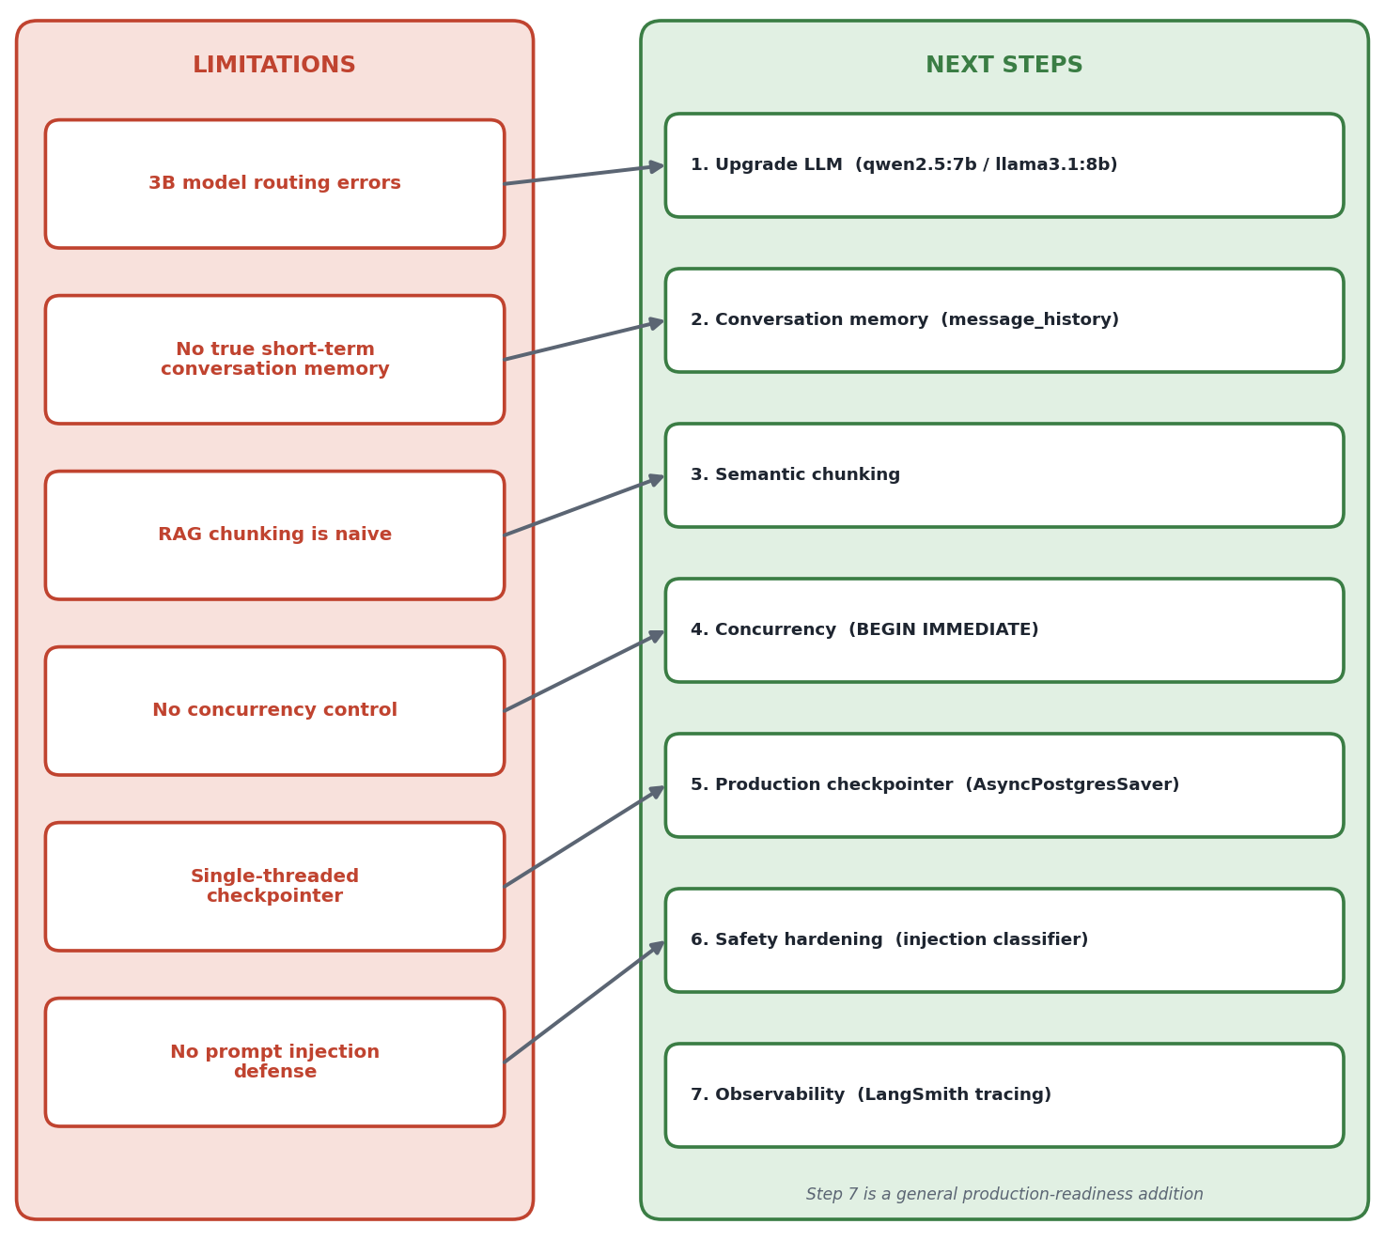
Figure 12: Mapping of documented limitations to the proposed next steps.

Appendix: Trace Evidence Samples

A.1 Trace: TC-1 Multi-turn Follow-up (TA2)
[check_inventory] 2x vada_pav(stock=25) -> OK
[process_order] 4 bids, winner=Flash Delivery
[confirm_order] status=CONFIRMED
>>> Follow-up: "add 2 misal_pav"
[check_inventory] 2x vada_pav(stock=23), 2x misal_pav(stock=30) -> OK
[process_order] 4 bids, winner=Flash Delivery
[confirm_order] status=CONFIRMED

State persisted via thread_id across turns.

A.2 Trace: TC-2 Restart & Resume (TA2)
=== Resume Menu ===
1. a1b2c3d4... | vada_pav, misal_pav | Manjari | pending_approval | 2026-10-19 14:32
Select: 1
[human_approval] status=PENDING Total=Rs.690
Approve? Y
[confirm_order] status=CONFIRMED

Checkpoint loaded from order_checkpoints table.

A.3 Trace: TC-3 RAG k=1 vs k=3 (TA2)
Q: "What is the shipping fee for 10km?"
k=1: [Policy 1, sim=0.57] "5 to 12 km: ₹35 flat fee"
k=3: [Policy 1, sim=0.57], [Policy 2, sim=0.52], [Policy 3, sim=0.35]

k=3 provides bidding + approval context for ShippingAgent.

A.4 Trace: TC-4 Tool Failure (TA2)
User enters: "Mars Colony"
Fuzzy match: "Did you mean Magarpatta City?" → Accept
[check_inventory] ... -> OK
[process_order] distance=12.8km, winner=Swift Logistics

A.5 Trace: TC-5 Approval Flow (TA2)
APPROVED PATH:
[check_inventory] 3x kolhapuri_chicken(stock=5) -> OK
[process_order] total=690, requires_approval=True
>>> PAUSED AT APPROVAL <<< Total: Rs.690
Approve? Y
[human_approval] status=APPROVED
[confirm_order] status=CONFIRMED

REJECTED PATH:
[check_inventory] 3x kolhapuri_chicken(stock=5) -> OK
[process_order] total=690, requires_approval=True
Approve? N
[human_approval] status=REJECTED
[decline_order] status=DECLINED (stock released)

